Name: ​ ​ Date: ​
​
The Art of Mick O’Dea
​
Meet the Artist! 🎨​

Answer the questions below based on what you have learned about the famous Irish artist, Mick O'Dea.  ​  1. Where in Ireland was Mick O'Dea born?  ​  2. What two things is Mick famous for wearing? | 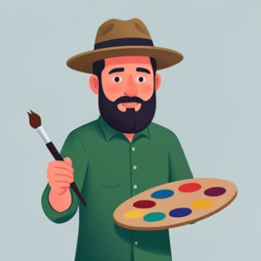
​
3. Mick painted a famous series about the Irish War of Independence. What did he look at to help him create these giant, colourful paintings?

​
Art Words Match-Up 📝​
​
Read the definitions below the pictures. Choose the correct art word from the word bank and write it in the space provided.

Word Bank:
1. En Plein Air 2. Subject 3. Impasto 4. Portrait

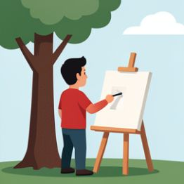 |  | 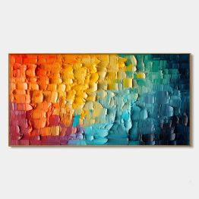 | 
Painting outdoors, on location. | A painting of a person. | Applying paint very thickly. | The main person or thing in a painting.
​
Your Turn to Paint! 🖌️​

💡​ | Artists use colours and styles to show a person's personality. Mick uses colours to show if someone is happy, serious, or thoughtful.
​
Think about a family member or friend you would like to paint a portrait of.

Who would you paint? What colours would you use to show their personality? Would you use thick (impasto) or smooth paint? Explain your choices.

Answer Key
​
Meet the Artist! 🎨​
​
Answer:
Ennis, County Clare.
​
Answer:
A hat and his beard.
​
Answer:
He looked at old black-and-white photos from 100 years ago.
​
Art Words Match-Up 📝​
​
Col 1: En Plein Air. Col 2: Portrait. Col 3: Impasto. Col 4: Subject.
​
Your Turn to Paint! 🖌️​
​
Answer:
(Student's own response, e.g., I would paint my sister. I would use yellow and orange because she is very energetic and happy. I would use smooth paint because she is also very gentle.)

