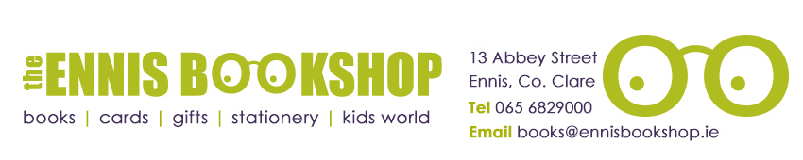

Book of the Month 10+

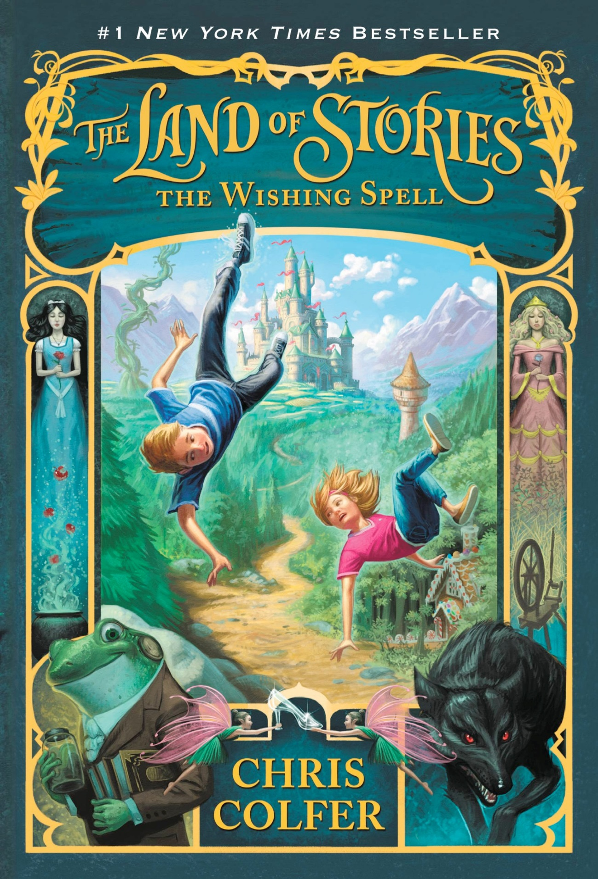
Was €10.95

ENNIS NATIONAL SCHOOL SPECIAL PRICE €8.75

The Land of Stories: The Wishing Spell by Chris Colfer

Alex and Conner Bailey's world is about to change. When the twins' grandmother gives them a treasured fairy-tale book, they have no idea they're about to enter a land beyond all imagining: The Land of Stories, where fairy tales are real. But as Alex and Conner soon discover, the stories they know so well haven't ended in this magical land - Goldilocks is now a wanted fugitive, Red Riding Hood has her own kingdom and Queen Cinderella is about to become a mother! The twins know they must get back home somehow. But with the legendary Evil Queen hot on their trail, will they ever find the way?

The Ennis Bookshop invites Ennis National School students to avail of a 20% DISCOUNT on our Book of the Month when you present this flyer in The Ennis Bookshop.

