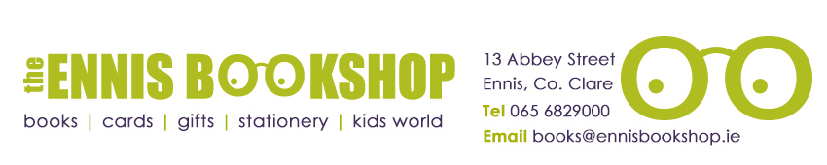

Book of the Month 8+

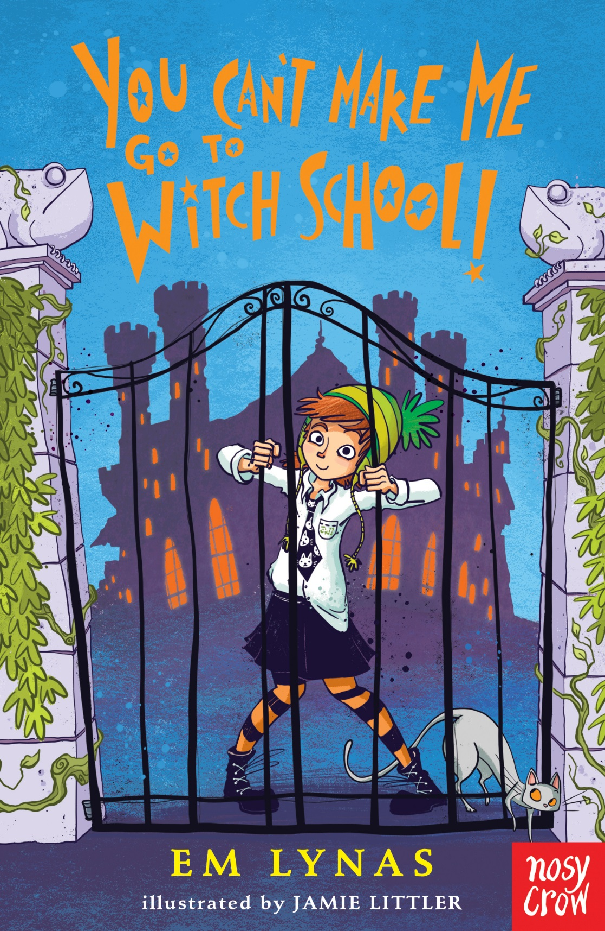

Was €9.60

ENNIS NATIONAL SCHOOL SPECIAL PRICE €7.65

You Can’t Make Me Go To Witch School by EM Lynas

Daisy Wart is NOT a witch! She is an ACTRESS! And actresses do NOT go to witch school! So when she finds herself at Toadspit Towers, sleeping in a swinging cauldron (surprising comfortable) and eating gloop (unsurprisingly disgusting), she vows to escape at all costs. But how can she get past the Toadspit Terrors that lurks in the corridors? And what if she really is a witch? Maybe even the Witchiest Witch of them all?

The Ennis Bookshop invites Ennis National School students to avail of a 20% DISCOUNT on our Book of the Month when you present this flyer in The Ennis Bookshop.

