
Recommended Reading List 8+

The BFB (Big Fat Baby) is missing! While Rover and friends are hot on the trail of the BFB, it looks like the Gigglers are about to run out of poo. Without an urgent delivery from Rover, how will they be able to give the Giggler Treatment to grumpy adults and help kids all over the country?
Mermaids Beattie, Mimi and Zelda are enjoying a summer on land with legs when they receive a strange crabagram ordering them to return home at once. Some seriously bad mermaids are on the loose and the girls are the only ones who can stop them.
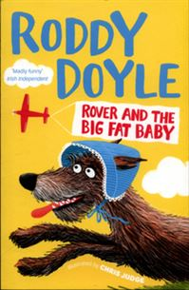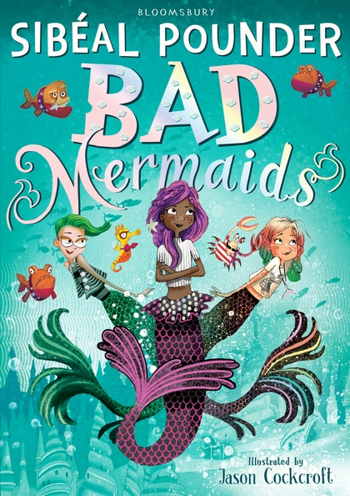

Why is Tommy the new boy at Colliery Primary School wearing a balaclava to school every day? And how come the teachers don’t make him take it off? The other kids are intrigued and come up with all sorts of theories, but every single one is wrong. As their curiosity grows, Dumisani and Doogle, aka the Doo dudes and best friends in the world, are determined to find out. Whatever it takes. Tommy's new friends think of a plan to reveal his secret, but you'll never guess what it is!

Andy and Terry live in the WORLD'S BEST treehouse! It's got a giant catapult, a secret underground laboratory, a tank of man-eating sharks and a marshmallow machine that follows you around and shoots marshmallows into your mouth whenever you're hungry! Just watch out for the sea monkeys, and the monkeys pretending to be sea monkeys, and the giant mutant mermaid sea monster.
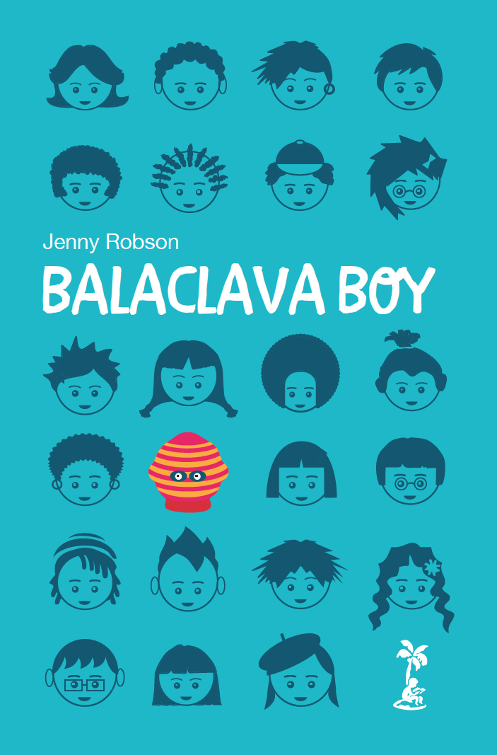

Joe, Beth and Franny move to the country and find an Enchanted Wood right on their doorstep. In the magic Faraway Tree live the magical characters that soon become their new friends including Moon-Face, Silky the fairy, and Saucepan Man. Together, they slide down the slippery-slip, and go to a fancy-dress feast in the Land of Birthdays! They visit other strange lands such as the Roundabout Land, Toyland and the Land of Take What You Want. They have the most exciting adventures – and narrow escapes!

Cass and her best friends, Lex and Nicholas, are the Bubble Street Gang! They investigate crimes, solve mysteries and have brilliant adventures. They’ve even got their own secret clubhouse.
There’s an intruder in the clubhouse! The gang find the door left open, crumbs on the table and hairs on the floor. Who has been sneaking in?
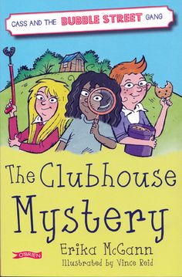

Dan is a teddy bear. He’s made for hugging. Aw, so cute, right? Wrong! Dan’s so strong he can crush cars but what makes him a faulty toy could make him the perfect spy. Together with a robot police rabbit and one seriously angry doll, Dan joins a top secret team designed to stop criminals in their tracks.
Bertie rescues an orphaned white lion cub from the African veld. They are inseparable until Bertie is sent to boarding school far away in England and the lion is sold to a circus. Bertie swears that one day they will see one another again, but the butterfly lion ensures that their friendship will never be forgotten.
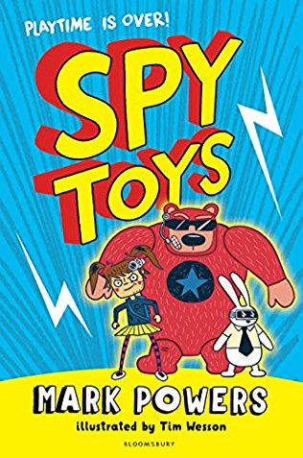

Barry Bennett hates being called Barry. In fact, it’s number 2 on the list of things he blames his parents for, along with (1) ‘being boring’ and (3) ‘always being tired’. But there is a world where parents don’t just have children. That’s far too random for something so big and important. Instead, children are allowed to choose their parents. For Barry Bennett, this world seems like a dream come true. Only things turn out to be not quite that simple……

Pippi lives in a house with a horse, a monkey, a suitcase full of gold and no grown-ups to tell her what to do. She’s wild and funny and her crazy ideas are always getting her into trouble!
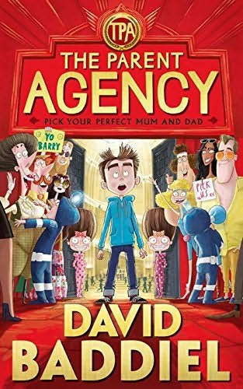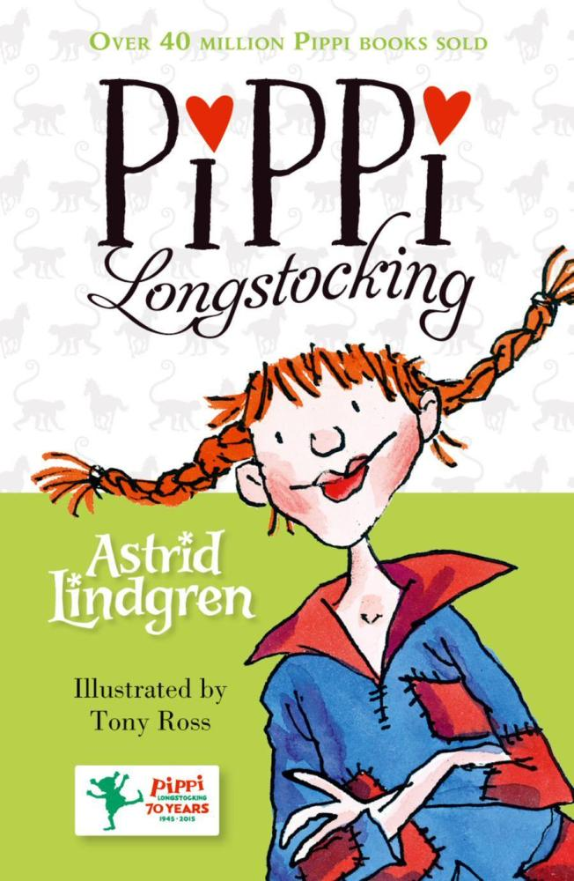

Meet Dave, the most terrible (as in rubbish) dragon in the land, terrible at all things dragony like hoarding gold and knitting. He dreams of being a bold, brave knight – wearing armour and protecting the kingdom from all evil-doers. With the help of his favourite book, Knighthood for Beginners, can Dave’s knightly dreams come true?
Meet Zoe. She’s got a lot of things to be unhappy about…Her stepmother is so lazy she asks Zoe to pick her nose for her. And the school bully loves flobbing on her head. Worst of all, the dastardly Burt has terrible plans for her pet rat.
