Book of the Month 8+

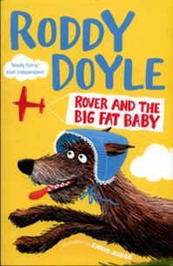

Was €8.20

ENNIS NATIONAL SCHOOL SPECIAL PRICE €6.55

Rover and the Big Fat Baby by Roddy Doyle

The BFB (Big Fat Baby) is missing! While Rover and friends are hot on the trail of the BFB, it looks like the Gigglers are about to run out of poo. Without an urgent delivery from Rover, how will they be able to give the Giggler Treatment to grumpy adults and help kids all over the country?

The Ennis Bookshop invites Ennis National School students to avail of a 20% DISCOUNT on our Book of the Month when you present this flyer in The Ennis Bookshop.

