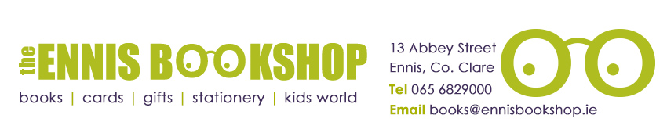

Book of the Month 10+

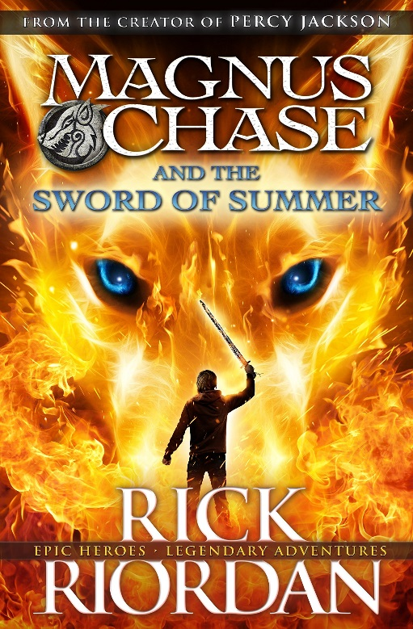

Was €10.95

ENNIS NATIONAL SCHOOL SPECIAL PRICE €8.75

Magnus Chase and the Sword of Summer by Rick Riordan

My name is Magnus Chase. I’m orphaned and living rough on the streets of Boston and things are about to get much worse. I was sleeping under a bridge when some guy kicked me awake and said ‘They’re after you’. Next thing I know, I’m reunited with my obnoxious uncle, who casually informs me that my long-lost father is a Norse god. The gods of Asgard are preparing for war. Apparently, if I can’t find the sword my father lost two thousand years ago, there will be doom. But first I’m going to die. This is the story of how my life goes downhill from there…

The Ennis Bookshop invites Ennis National School students to avail of a
20% DISCOUNT on our Book of the Month when you present this flyer in The Ennis Bookshop.

