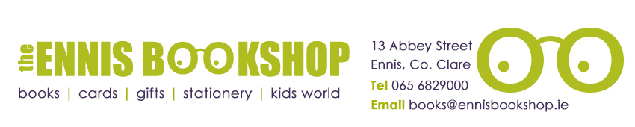

Book of the Month

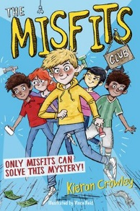
Was €8.50

ENNIS NATIONAL SCHOOL SPECIAL PRICE €6.80

The Misfits Club by Kieran Crowley

When Brian, Hannah and twins Chris and Sam start their summer holidays, they know it’s the end of an era. The Misfits Club is disbanding and they still haven’t managed to solve any real mysteries. But when they persuade new club member Amelia to go and investigate a spooky old house, they unexpectedly discover some stolen goods. Could this be their chance for one last adventure?

The Ennis Bookshop invites Ennis National School students to avail of a 20% DISCOUNT on our Book of the Month when you present this flyer in The Ennis Bookshop.

