

Book of the Month

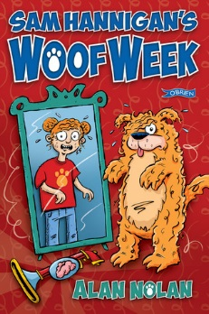
Was €8.99

ENNIS NATIONAL SCHOOL SPECIAL PRICE €7.15

Sam Hannigan’s Woof Week by Alan Nolan

Animal lover and champion Irish dancer Samantha Hannigan is having a truly woof week. She and her best friend Ajay were messing around with the Brain Swap 3000 – one of her grandad’s crackpot inventions – and now Sam is stuck inside the body of Barker, her neighbour’s dog! How long can they pretend Sam is just dressing up in a dog costume? Are her chances of winning the big dance competition scuppered? What’s going on behind closed doors at Roger Fitzmaurice’s dog biscuit factory? And why has Sam suddenly started to chew on slippers and bark at the moon?

The Ennis Bookshop invites Ennis National School students to avail of a 20% DISCOUNT on our Book of the Month when you present this flyer in The Ennis Bookshop.

